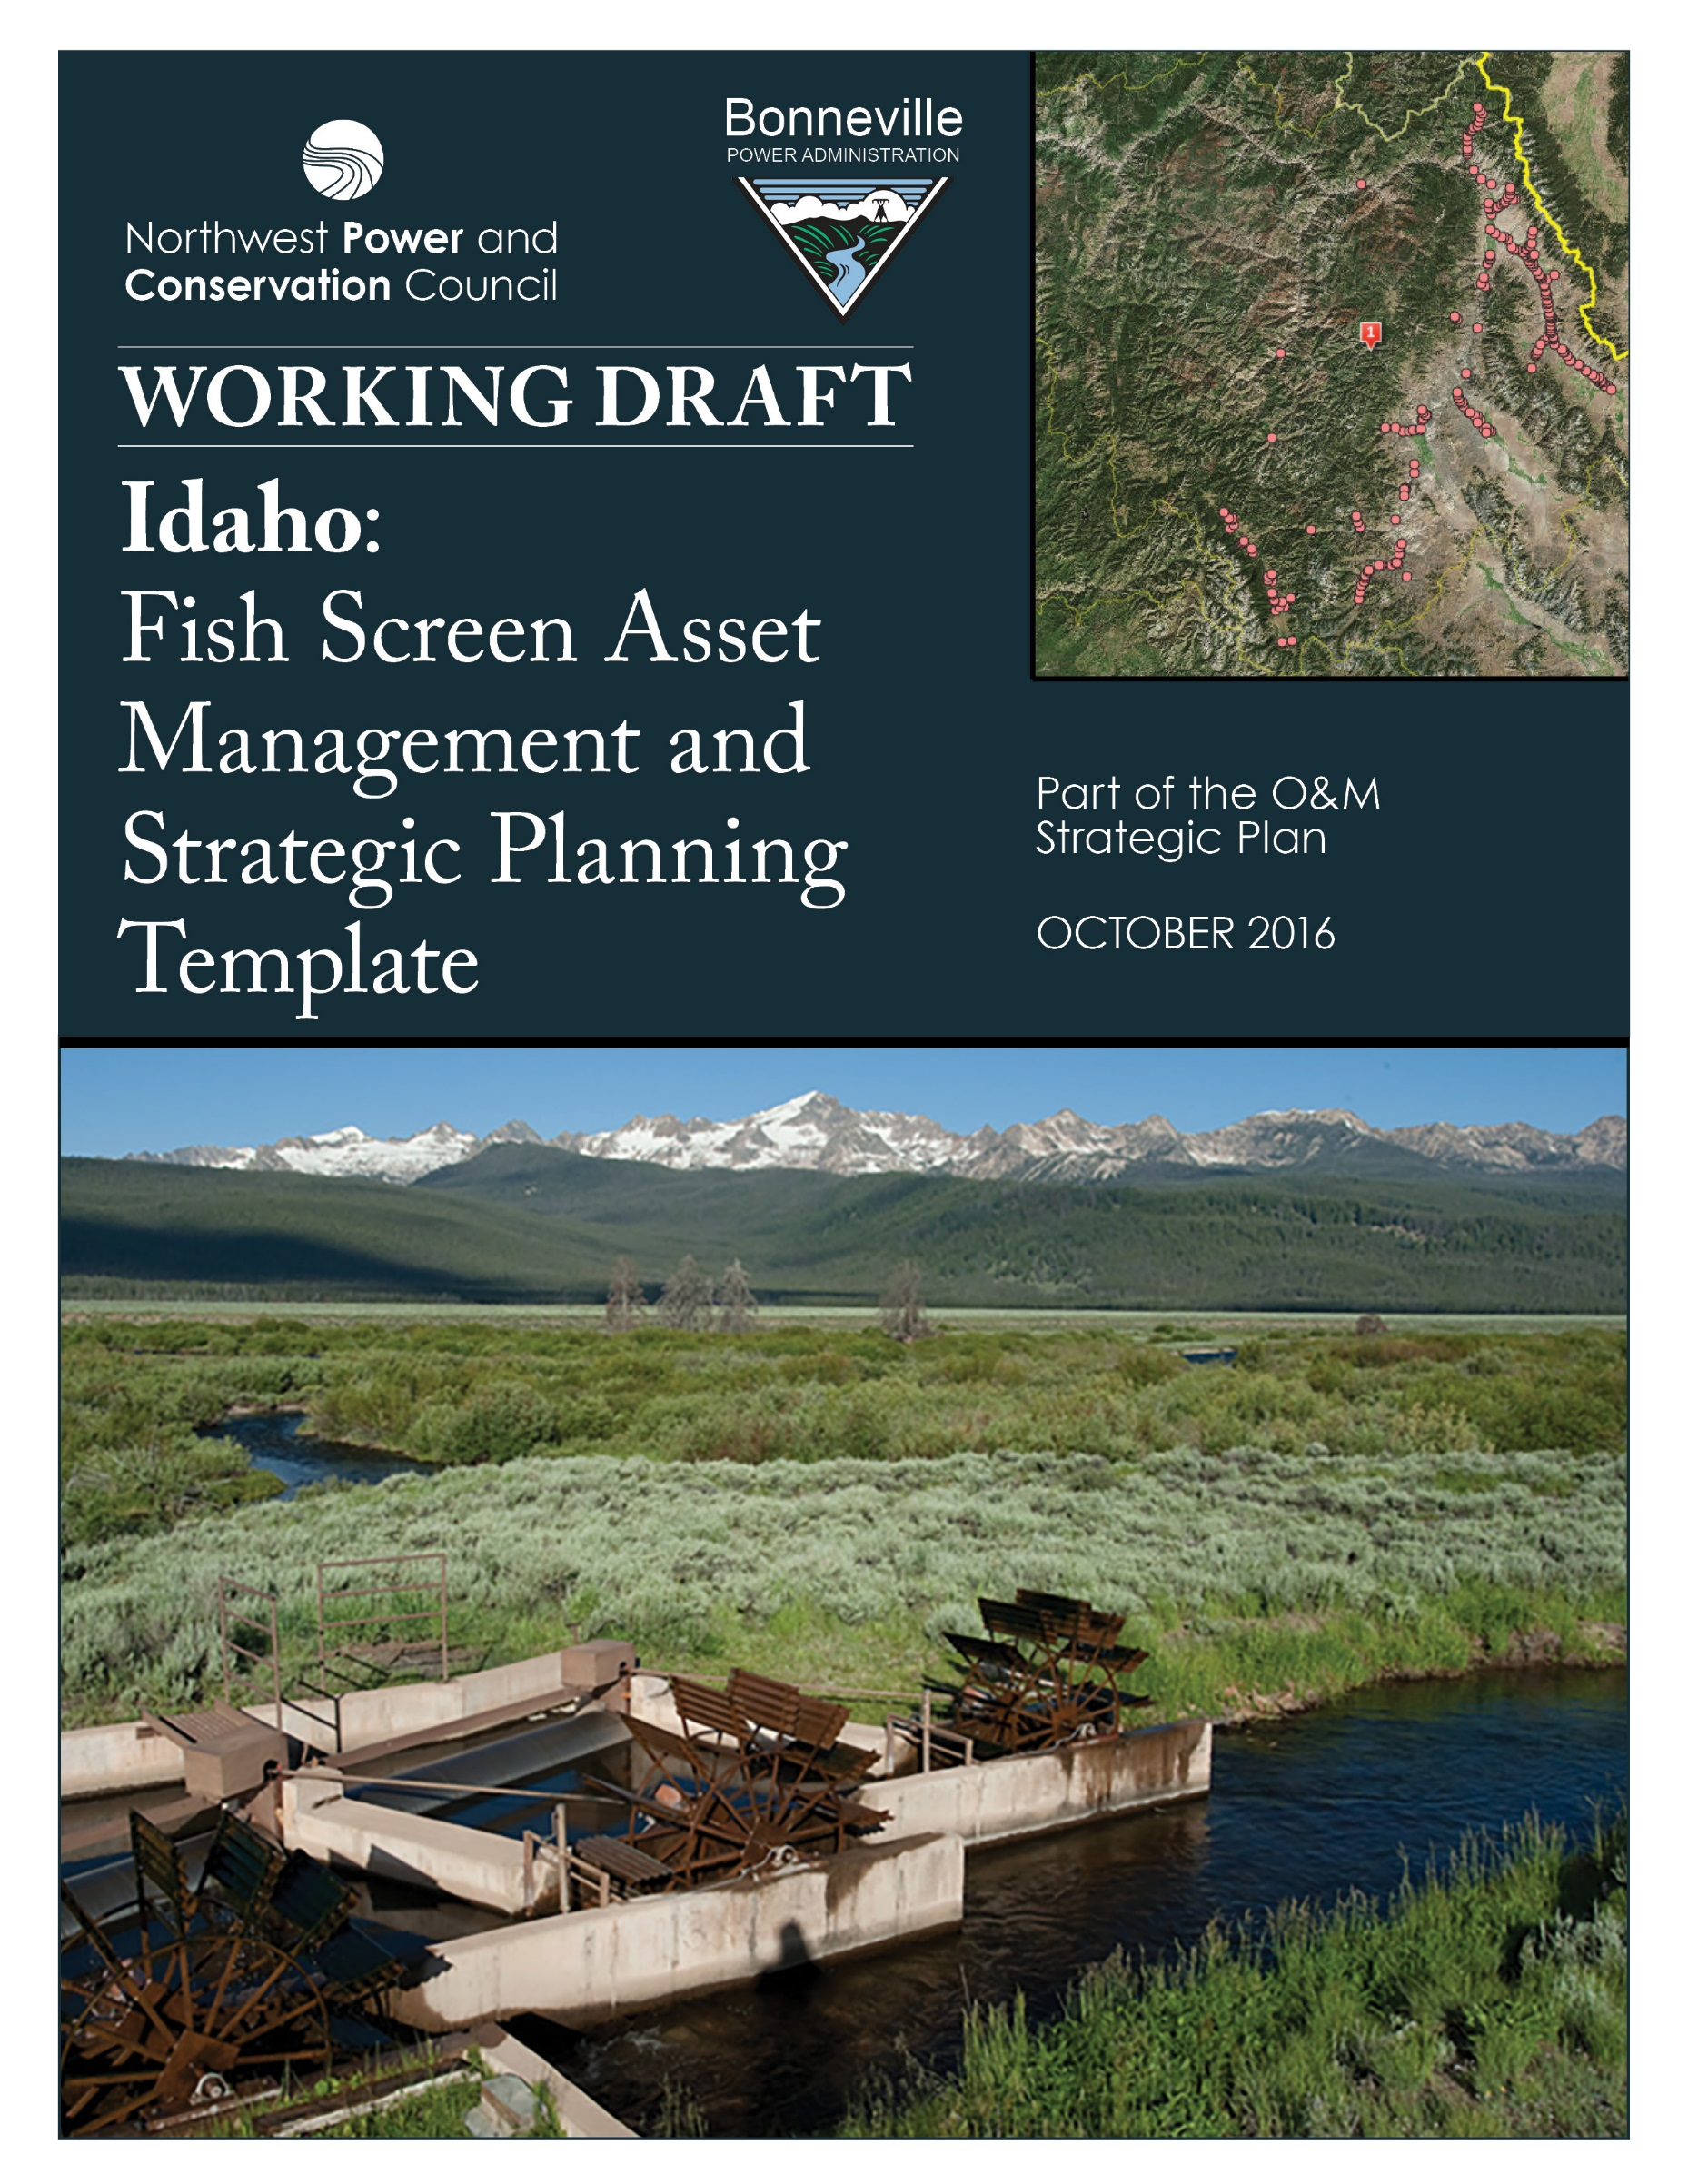
IDAHO FISH SCREEN ASSET MANAGEMENT AND
STRATEGIC PLANNING TEMPLATE

Entity: Idaho Department of Fish and Game, Anadromous Fish Screen Program

Entity Contact: Patrick (Paddy) Murphy, Program Coordinator
Anadromous Fish Screens, Passage, and Habitat Program
Idaho Department of Fish and Game, Salmon, Idaho 83467
208-756-6022 patrick.murphy@idfg.idaho.gov

Number of Fish Screens in this Inventory: 261 fish screens – see screen inventory Appendix 1 and 2 for more detailed information.
IDFG Fish Screen Program Budget: Approximately $2,448,409 in 2016.
Primary Funding Sources: BPA approximately 54% of funding in 2016 with $1,315,400. Mitchell Act with NOAA/NMFS 46% of funding in 2016. with $1,133,009,

Relevant BPA Projects and Budgets:

- BPA Project #1994-015-00, Idaho Fish Screening Improvement,
2016 Total Project Budget $434,633 expense funding of which $320,000 is line-itemed for the Screen Program.

- BPA Project #2007-399-00 Upper Salmon Screen Tributary Passage,
2016 Total Project Budget $995,400 expense funding.

Funding Trend / Issue: Mitchell Act funding reductions reducing total funding and amount of funding from NOAA/NMFS has decreased 22% over last five years. IDFG is focused on strategic planning and asset management to enhance its ability to operate and maintain its fish screen program.

General Background:

The Idaho Department of Fish and Game’s (IDFG) Anadromous Fish Screen Program designs, fabricates, installs, operates and maintains fish screens and fish passage ways in Idaho. Currently, the Program operates and maintains an inventory of 261 fish screens in the Upper Salmon River Basin that were cooperatively funded by National Marine Fisheries Service’s (NMFS) Mitchell Act and Bonneville Power Administration (BPA). These include maintaining fish screens on the Lemhi River, Pahsimeroi River, North Fork Salmon River, East Fork Salmon River, mainstem Salmon River, and over 25 associated tributaries. Since 1992, a partnership between NMFS, BPA, and Idaho Department of Fish and Game (IDFG) has built a successful Fish Screening Program with commitments and easements with landowners. This success is based on years of building trusted relationships with irrigators on private property. Building relationships and landowner cooperation has been paramount to the Program’s success as most of the Chinook salmon spawning habitat occurs on private property, with close to 100% in the Lemhi, Pahsimeroi and North Fork Salmon Rivers. Due to extensive flood irrigation in the Upper Salmon River Basin, the Screen Program is a principle foundation for the recovery of four ESA-listed anadromous salmonids including Chinook salmon, steelhead, sockeye salmon, and bull trout which are protected from entrainment threats by maintaining the Programs’ fish screen inventory.

Fish screens are important to prevent fish from being stranded in irrigation channels or canals when water is diverted or pumped from streams. Fish screens are built according to criteria approved by NMFS to help maintain water velocities evenly across the screen surface, preventing higher velocity points from impinging fish to the screen. Fish screens installed by IDFG help ensure safe passage of juvenile and adult fish which contributes to salmon recovery and works in conjunction with habitat restoration activities.

IDFG Screen Program History:
This program started in 1957, and for the first 34 years, until 1992, the IDFG Screen Program was funded with 100% NMFS administered Mitchell Act Funding. In 1991, Northwest Power and Conservation Council (NWPCC) directed the Columbia Basin Fish and Wildlife Authority (CBFWA) to coordinate the Idaho/Oregon/Washington Fish Screen Programs through the establishment of the Fish Screen Oversight Committee (FSOC) and BPA began providing funding for new fish screens in the Upper Salmon River Basin. In 1992, the IDFG Screen Program started replacing all of it’s fish screen inventory with new designs that met new screen criteria established by NMFS and FSOC. In 1993, BPA and Mitchell Act funded a new 8500 square foot shop, and new tools and equipment to meet the accelerated goals of replacing all screens with new criteria screens. The Screen Program is currently working with partners in 20 tributary watersheds to reconnect habitat and improve fish passage and instream flows for anadromous salmonids. The program has 12 classified employees and 17 temporary employees. Two BPA Projects provide funding to the screen program: Idaho Fish Screening Improvement (#1994-015-00) and Upper Salmon Screen Tributary Passage (#2007-399-00).

IDFG Screen Program Funding History:
From the inception of the Program, from 1957 to 1990, the entire budget for the IDFG Screen Program was NMFS Mitchell Act funding. From 1991 to present, the Program has been funded cooperatively by BPA and NOAA’s Mitchell Act to include the current inventory of 261 fish screens. In the screen replacement phase of the early 1990’s, most of the personnel, operation and maintenance, and capital funding was paid by Mitchell Act, with additional personnel and operating support in topographic surveys, permitting, final designs, construction equipment, and the new shop funded by BPA. As costs increased into the late 1990’s, more Mitchell Act funding was allocated to personnel and operating costs, with almost all of the new capital costs and operating support now being funded by BPA. In 2007, BPA separated out the capital projects in a new project, Upper Salmon Screen Tributary Passage (#2007-399-00) with almost all new projects being funded by BPA but being maintained by operation and maintenance funding of Mitchell Act. Over the last five years, BPA has funded approximately 80% of the capital costs, 30% of the operating cost, and 25% of the personnel costs for the IDFG Fish Screen Program.
In the last 5 years, annual Mitchell Act funds for the IDFG Program have decreased by 22%, with a decrease of 16% in 2014 alone. In 1995, the Mitchell Act Budget for the IDFG Fish Screen Program was $1.5 million, down to $1.033 million in 2014. For IDFG, Mitchell Act has no current budget for capital projects and is strictly for personnel and operating, with any reduction coming out of an already depleted operating budget. This has been a very successful program, and the costs that drive the program are the temporary workforce, and the cost of steel and gasoline, all which have risen 2-3 times since the mid-1990’s. We believe we have a very reliable business model, largely due to the funding and success of our operation and maintenance program.
In 1996, Mitchell Act funding for the Program was 1.5 million, with 750 k in personnel, 750 k in operating/capital. Operating costs have doubled since the mid-1990’s including steel, gasoline, and propane. Fleet/gasoline, steel, and propane charges currently account for 2/3 of operating budget. The average benefit rate for personnel has increased 25-40% since the mid-1990’s.

The current overall costs of combined funding for the Screen Program to provide the minimum adequate services to maintain our fish screen inventory and continue to improve the survival of anadromous salmonids are listed below.

Personnel  12 Classified Employees  17 Temporary Employees | Operating  No Overhead | Capital | Total Annual Budget
$1,500,000 | $350,000 | $600,000 | $2,450,000

A significant cost savings in the Program is that all operating and raw materials, including; power train parts (gear boxes, drive chains, bearings, sprockets, electric motors, bolts and nuts, drive line yokes, and u-joints), dimensional steel, sheet steel, and stainless steel perforated plate is paid for with Mitchell Act funding. These materials are used for operation and maintenance of existing screens and for building new screens. When a new screen is built using BPA Capital funding only the cost of materials is charged for reimbursement to the Program as the personnel and associated overhead costs (~20% of overall capital cost ) has already been funded by Mitchell Act. All the construction crew staff; the Construction Supervisor, Construction Foreman, and Four Utility Craftsmen are funded 100% with Mitchell Act funding.

Operation and Maintenance:
For over 57 years, Mitchell Act has provided all of the operation and maintenance funding for all fish screens. BPA has provided funding for new fish screens but no funding for O&M.

The IDFG Fish Screen Program has an operation and maintenance program with 12 Screen Tenders that actively maintain the 261 fish screens on a daily basis through the 8 month irrigation season, typically March 15 until late October/early November. A majority of the fish screens are maintained 4 to 5 times a week, with larger screens maintained every day to assure that the screens are operating to the design criteria and protecting fish. The overall costs for the Screen Tender salaries, benefits, screen parts, and operating costs is ~ $600,000 annually. Each fish screen costs about $2,000 in screen tender salaries and additional operating costs to maintain through an 8 month irrigation season. This annual operation and maintenance cost is only 2-3% of the overall replacement cost of the 261 fish screens the program maintains. A minimum replacement value estimate on the screen inventory is $30,000,000.

Screen Tender and O&M are vital to the Program’s success and a relatively cheap cost to protect the substantial investment of these capital projects. With proper operation and maintenance the effective life of a fish screen can be at least 20-25 years, without it, there are no guarantees the fish screen will be operational after one season of high water. Daily O&M will at least double the expected functional life of a fish screen. Additionally, the lack of fish screen maintenance could potentially erode the established trust with landowners and irrigators

The average age of the larger, mainstem IDFG fish screens is 18 years old, with 25% of the inventory being 20 years old or older. We feel strongly that we can maximize the longevity of these structures if we can maintain our current operation and maintenance practices and temporary workforce. If the total annual budgets remain stable and with an annual capital budget of $600,000 we feel we can responsibly start replacing fish screens when the integrity of the structure is finally compromised. The estimate on fish screen longevity is not exact, as some screens may need replacement at 25 years and others at 40 years of age before total replacement is needed. We believe we can continue to work with partners to improve fish passage and increase egg to smolt survival in currently unscreened tributaries in the next five years and as needed incorporate fish screen replacements to keep the Screen Program as efficient and productive as possible.

In the near future, we can predictably replace older infrastructure at about 80-100 cfs (cubic feet per second) of fish screen capacity a year at an approximate cost of $7,000 a cfs (includes all costs, including personnel). This would be at a replacement rate of 6 fish screens a year that would average about 15 cfs in average size. This would be appropriate as 25% (66 fish screens) of the inventory being 20 years old or older could be replaced easily in the next 10 years at the current funding levels of $2.45 million with at least $600,000 in capital funding.

The Screen Program has only eight fish screens in the inventory (3%) that are designed over 50 cfs, with three of these being over 100 cfs. When these fish screens need to be replaced, hopefully not in the next 10-15 years, there will need to be substantial prior planning as they will need utilize almost all of the current capital funding, especially the largest three structures.

Data Management of Fish Screen Data:

IDFG maintains its own database of the 261 fish screens in its inventory. This internal database includes detailed information on each fish screen. The database also maintains records of easements with landowners for the fish screens.

IDFG also enters information about fish screens into the BPA Pisces project system when it provides information about installation of fish screens and to operate and maintain fish screens. Location and metric information is entered by IDFG into Pisces and can be a source of information of fish screen work funded by BPA.

As part of this initiative, the Northwest Power and Conservation Council also worked with BPA to utilize a 2016 fish screen inventory from QW Consulting to develop an online map of fish screens available to the public on the Council website. The website shows the fish screens as points on the map, and allows the user to obtain additional information by clicking on the point. In addition, the map allows the user to zoom into the specific location of the screen using the google map interface. A link and screen example is shown in Appendix 2.

In future years, it may be possible to update the 2016 inventory of fish screens from QW Consulting through coordination with the Fish Screen Oversight Committee (FSOC). This may involve leveraging data in regional databases, and enabling updated data to be reflected in map interfaces, such as the one now available on the Council website.

IDFG Fish Screening Budget Forecast:

IDFG statement that reflects information in Appendix 2 regarding non-recurring and normal weekly maintenance in the next 5-10 years.

IDFG Statement Regarding O&M Responsibilities:

IDFG statement regarding any statutes, regulations, or agreements that drive the need for fish screens and the responsibility for O&M and replacement of fish screens.

Fish Screen Prioritization Criteria:

IDFG seeks to maintain its inventory of 261 screens. Most of these screens are drum screens constructed and installed by IDFG.

In prioritizing screens for operation and maintenance, IDFG would be most focused on fish screens benefiting Columbia Basin salmon Evolutionary Significant Units (ESUs), mainstem screens sized over 30 cfs, and other specific fish screens that prevent the highest rates of mortality at key times for fish.

The Appendix 2 document prioritizes fish screens primarily based on size of the screen for screening ESA listed salmon, and takes into account biological importance and O&M budgeting needs.

Use of BPA Funding for IDFG Fish Screening:

In 2017, BPA is providing $1,315,400 in project funding for IDFG fish screens through two projects.

Project #1994-015-00, Idaho Fish Screening Improvement and Project #2007-399-00 Upper Salmon Screen Tributary Passage are focused on providing management and operational support for a capital construction program dedicated to the protection of anadromous fish from loss in water diversions, improve fish passage at diversions for juvenile and adult anadromous fish, and improve stream flow conditions where possible.

Fish Screen Budgeting Considerations:

IDFG is facing the prospect of reduced Mitchell Act funding from NOAA/NMFS. Even with stable funding from BPA, IDFG may have challenges in operating and maintaining its current inventory of 261 fish screens and continuing to install additional fish screens.

The need may exist for IDFG to prioritize available fish screen funding in terms of specific screens to be maintained, type and frequency of maintenance of existing screens, and extent of new screens to be installed.

Consideration of new screens may be dependent on identifying a funding source or landowner responsible for operation and maintenance costs of a fish screen at a particular water diversion.

Listings of lamprey or other fish species could create budget issues for IDFG fish screens if existing screens do not comply with any new fish screen criteria. The appendix document provides information on IDFG’s compliance with current NOAA fish screen criteria for the specific screens in the inventory. NOAA fish screen criteria were updated in the 1990s and have not gone through formal rule-making. The NOAA fish screen criteria provide guidance to agencies for installing fish screens.

Consideration of additional cost-share sources and landowner cost-share may also be useful.
Appendix 1: Map of Idaho Fish Screens
An interactive Fish and Wildlife Program Resource Map of Fish Screens has been developed in September 2016 (www.nwcouncil.org/fw/program/maps). IDFG screens are located in Idaho with the dots shown in the area of the number 1 label in following map excerpt.
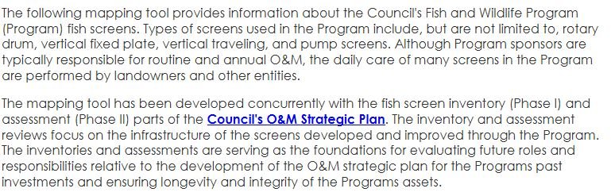
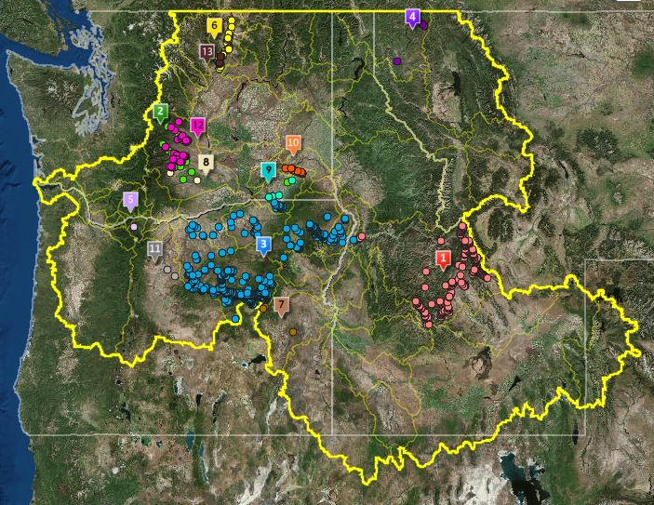
www.nwcouncil.org/fw/program/maps

